Biology (study of living organisms)

Benthic Macro Invertebrates
Benthic- bottom dwellers
Macro- seen with eye
Invertebrate- an insect having no backbone
Macros are great indicators or signals that help scientists determine if a body of water is healthy or not. Healthy means having enough oxygen, a pH level between 5 and 9, not too many salts and minerals being dissolved in the water, and not too much human “stuff” thrown into the water system.
Three really cool looking and acting macros we can use to determine if the water is healthy are illustrated below.
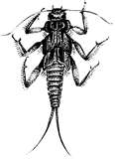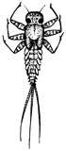
Caddis Fly Larva
May Fly Nymph
Stone Fly Nymph

YOUR TASK:
- Using ONLY 4 pipe cleaners make a model or simulation of one of these macros
- Show your teachers
- Make the other ones using only 4 pipe cleaners for each
- Next, choose one and using the handout, re-draw each phase of its life cycle, make sure to include labels on your illustration and discuss with your partners how their physical body changes so much in each phase

